Ryan Helmlinger

Period 3

5/2/16

Distance: 86757.10368811741

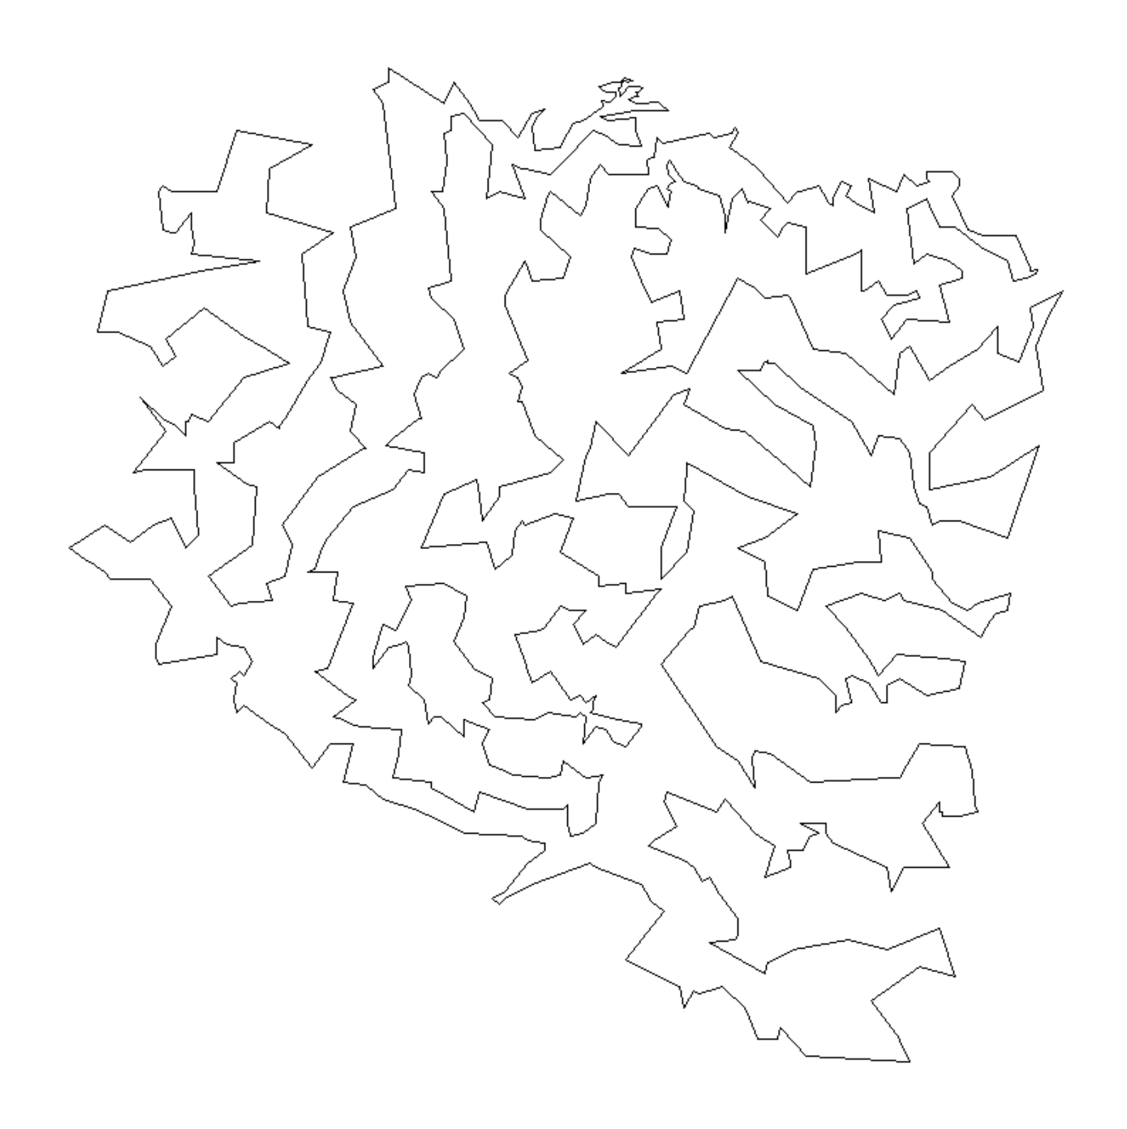

I ran a loop 10 times to find the best path. I first swap values in the list in order to find a better path. Then I untangle the list, which will automatically decrease the path length because intersections take up more distance. Then loop through each set of 4 segments of the path and go through each of the permutations of the four points. I find the permutation with the smallest distance and then edit the path with that new segment. To finish the program, I untangle the graph once again just to make sure no more intersections popped up.

[1, 2, 7, 5, 4, 8, 10, 15, 12, 13, 9, 14, 20, 29, 31, 38, 42, 49, 37, 33, 30, 32, 35, 48, 52, 57, 59, 61, 64, 78, 87, 94, 101, 102, 129, 128, 116, 136, 144, 164, 158, 172, 185, 188, 197, 193, 206, 216, 222, 228, 214, 204, 210, 221, 249, 279, 278, 285, 293, 297, 302, 318, 309, 319, 327, 303, 315, 349, 362, 361, 358, 388, 415, 403, 393, 385, 396, 397, 407, 398, 427, 444, 456, 466, 482, 464, 452, 440, 461, 468, 467, 495, 516, 524, 531, 540, 553, 565, 546, 545, 549, 593, 608, 594, 595, 667, 652, 634, 566, 547, 532, 471, 469, 445, 425, 404, 394, 391, 399, 382, 367, 366, 354, 350, 307, 282, 250, 254, 258, 275, 283, 308, 320, 356, 376, 377, 389, 409, 420, 428, 429, 441, 474, 496, 528, 554, 568, 692, 712, 723, 734, 693, 724, 694, 675, 676, 656, 684, 689, 680, 670, 648, 649, 662, 673, 677, 686, 690, 699, 698, 700, 703, 707, 706, 711, 716, 722, 725, 726, 732, 733, 731, 730, 728, 729, 727, 717, 714, 702, 710, 713, 718, 719, 720, 721, 715, 709, 708, 705, 704, 701, 695, 696, 697, 691, 687, 685, 688, 682, 681, 674, 678, 672, 666, 651, 654, 660, 669, 657, 647, 626, 636, 635, 639, 583, 597, 582, 653, 683, 679, 668, 661, 641, 603, 596, 569, 505, 502, 487, 477, 457, 437, 431, 433, 430, 417, 406, 405, 383, 380, 373, 359, 363, 347, 333, 311, 299, 290, 286, 287, 288, 259, 255, 201, 198, 177, 173, 152, 148, 145, 141, 138, 122, 106, 103, 99, 96, 82, 97, 88, 89, 90, 70, 62, 65, 71, 104, 113, 108, 119, 112, 107, 111, 114, 117, 130, 139, 149, 135, 154, 153, 146, 174, 183, 194, 219, 225, 223, 218, 202, 211, 217, 238, 232, 260, 273, 276, 264, 241, 226, 203, 189, 175, 166, 155, 150, 159, 156, 160, 157, 131, 137, 142, 140, 134, 132, 125, 143, 147, 151, 161, 163, 168, 179, 167, 178, 176, 200, 186, 199, 207, 230, 233, 235, 251, 243, 244, 239, 224, 231, 227, 220, 268, 272, 267, 277, 274, 284, 300, 328, 329, 321, 324, 316, 298, 291, 310, 304, 344, 355, 341, 323, 334, 342, 351, 360, 369, 386, 414, 413, 423, 432, 434, 450, 484, 491, 525, 521, 506, 510, 529, 550, 561, 587, 598, 563, 574, 620, 638, 625, 627, 628, 629, 644, 645, 646, 658, 655, 663, 659, 664, 671, 665, 650, 642, 637, 578, 600, 601, 611, 579, 575, 584, 617, 612, 589, 580, 567, 590, 621, 602, 630, 613, 618, 622, 632, 633, 623, 614, 591, 551, 543, 544, 522, 519, 520, 515, 513, 509, 518, 527, 539, 559, 558, 576, 585, 572, 523, 536, 526, 517, 512, 504, 476, 480, 470, 465, 479, 485, 490, 500, 494, 493, 508, 499, 498, 537, 535, 514, 557, 560, 556, 542, 562, 571, 581, 577, 607, 586, 548, 564, 588, 604, 610, 616, 624, 643, 640, 631, 619, 615, 606, 599, 592, 573, 609, 605, 570, 555, 552, 541, 534, 533, 538, 530, 507, 486, 497, 478, 475, 458, 435, 442, 436, 511, 503, 488, 492, 489, 459, 453, 419, 454, 462, 426, 443, 460, 472, 455, 449, 473, 483, 501, 481, 463, 421, 402, 412, 375, 348, 357, 379, 314, 326, 325, 322, 337, 338, 353, 374, 384, 387, 372, 401, 424, 447, 446, 451, 448, 439, 438, 411, 395, 381, 352, 365, 390, 392, 410, 416, 422, 418, 408, 371, 400, 378, 370, 339, 345, 346, 335, 336, 330, 305, 280, 301, 332, 340, 364, 368, 343, 331, 312, 306, 294, 266, 245, 292, 295, 296, 317, 313, 289, 281, 256, 247, 257, 271, 248, 242, 240, 229, 246, 263, 270, 262, 269, 253, 237, 212, 196, 215, 213, 209, 182, 181, 192, 184, 171, 170, 187, 195, 191, 169, 165, 162, 180, 190, 208, 265, 261, 252, 236, 234, 205, 126, 120, 100, 121, 124, 123, 105, 109, 110, 118, 133, 127, 115, 91, 86, 81, 80, 79, 85, 84, 93, 77, 47, 46, 36, 45, 58, 68, 76, 75, 74, 73, 72, 67, 63, 54, 53, 50, 44, 41, 56, 66, 95, 83, 98, 92, 69, 60, 55, 51, 43, 39, 40, 34, 28, 26, 24, 23, 17, 19, 21, 25, 22, 27, 16, 18, 11, 6, 3]